INTEL PROCESSOR ARCHITECTURES

Submitted to:  DR.DURU ARUN KUMAR | Submitted by:  MANISH KUMAR GUPTA  COE-I  260/CO/08  APRIL 2010
CONTENTS
ABSTRACT | 3
INTRODUCTION | 4
- P6 Family Micro architecture | 5
- Intel NetBurst Micro architecture | 6
2.1 The Front End Pipeline | 6
2.2 Out-Of-Order Execution Core | 7
2.3 Retirement Unit | 7
- Intel Core Micro architecture | 8
- Intel Atom Micro architecture | 9
- Intel Hyper-Threading Technology | 10
- SIMD Instructions | 11
- Multi-Core Technology | 12
- Intel 64 Architecture | 13
SUMMARY | 14
APPENDIX | 15
a-1 SIMD eXTENSIONS, REGISTER LAYOUT & DATATYPES | 15
A-2 INTEL 64 & INTEL IA-32 PROCESSORS THAT SUPPORT DUAL CORE | 16
A-3 INTEL 64 PROCESSORS THAT SUPPORT QUAD CORE | 16
A-4 INTEL IA-32 & INTEL 64 PROCESSORS WITH THEIR ARCHITECTURE AND FEATURES | 17
A-5 INTEL IA-32 & INTEL 64 PROCESSORS WITH INSTRUCTION SET USED | 18
SOURCES | 19
GLOSSARY | 20
INDEX | 21
ABSTRACT

This report aims to study and gain knowledge about the architecture of the Intel microprocessor (processor) which is the brain of a computer. A microprocessor incorporates most or all of the functions of a computer's central processing unit (CPU) on a single integrated circuit (IC, or microchip).
Processor technology is dominated by two major companies: INTEL and AMD. This report deals with the Intel line of processors and tells about the basic architectural features of the processors. Beginning with the architecture of the Intel Pentium processor and its successor processors (known as P6 Family), the report then deals with the Intel NetBurst & Core architecture. This report also studies the technology related to the development of more advanced processors namely, Hyper-Threading and SIMD instructions. Lastly, it incorporates details of the Multi-Core & Intel 64 architecture.
INTRODUCTION
The purpose of this report is to get knowledge of architectural details of the Intel microprocessor. Intel Corporation was founded by Gordon E. Moore and Robert Noyce. Intel through the years has been guided by Moore’s law which states “complexity of an integrated circuit, with respect to minimum component cost, doubles every two years”.
The line of Intel microprocessors started with the development of Intel 4004 microprocessor which consisted of 4-chip architecture, first made the 4-bit CPU, second the ROM chip for storing programs, third the dynamic RAM for storing data & fourth was the simple I/O device. Later with the development of 8008 & 8080 microprocessors, which had 8-bit base architectures, came the 8085 microprocessor that formed the base of the 16-bit architecture of 8086. Intel 8086 was followed by the Intel x86 family which included the 80186, 80286, 80386, 80486 processors.
The report discusses the architecture of the Intel Pentium microprocessors known as the P6 family. The P6 family was the first 32-bit family known to be having x86 architecture. P6 processor architecture introduced the concept of out-of-order execution incorporating deep branch prediction, dynamic data flow analysis & speculative execution of instructions.
After this, the report discusses the NetBurst architecture which has some modifications in the pipeline structure like branch prediction, dynamic execution core facilitating parallel execution & an improved retirement unit.
Then the Intel Core architecture is discussed which has lower power consumption & improved pipeline bandwidth for fetch, dispatch and execution of data in high bandwidths. It supports smarter memory access with an advanced cache system to improve data flow between L2 and L1 cache. It has advanced SIMD instructions to improve throughput.
The Intel Atom architecture is extremely power efficient as it incorporates a bigger pipeline structure, smarter cache system, efficient memory access & digital media boost.
Later, the technologies which enabled further advancement in microprocessor architecture are discussed. These are Hyper-Threading technology & improved SIMD instructions.
Then the Multi-Core micro architecture is discussed. It provides hardware capability for multi threading. It uses two processor cores within the same physical package that use the hyper-threading technology. Lastly, Intel 64 architecture, the most advanced architecture till date is discussed.
1. P6 Family Micro architecture
The Pentium Pro processor introduced a new micro architecture commonly referred to as P6 processor micro architecture. The P6 processor micro architecture was later enhanced with an on-die, Level 2 cache, called Advanced Transfer Cache. The micro architecture is a three-way superscalar, pipelined architecture, meaning that by using parallel processing techniques, the processor is able on average to decode, dispatch, & complete execution of (retire) three instructions per clock cycle.
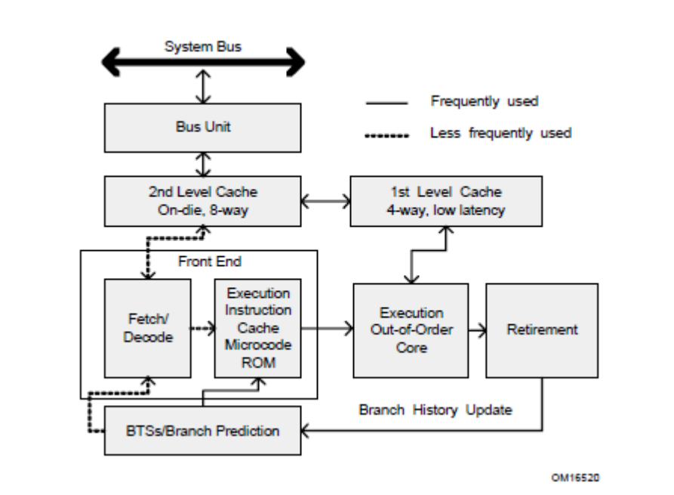
Figure 1. The P6 Processor Micro architecture with Advanced Transfer Cache Enhancement

To ensure a steady supply of instructions & data for the instruction execution pipeline, the P6 processor micro architecture incorporates two cache levels. The centerpiece of the P6 processor micro architecture is an out-of-order execution mechanism called dynamic execution. Dynamic execution incorporates three data processing concepts:
- Deep branch prediction allows the processor to decode instructions beyond branches to keep the instruction pipeline full.
- Dynamic data flow analysis requires real-time analysis of the flow of data through the processor to determine dependencies & to detect opportunities for out-of-order instruction execution. Out of order execution core can monitor many instructions & execute these instructions in the order that best optimizes the use of the processor’s multiple execution units, while maintaining the data integrity.
- Speculative execution refers to the processor’s ability to execute instructions that lie beyond a conditional branch that has not yet been resolved, & ultimately to commit the results in the order of the original instruction stream. For this the P6 processor micro architecture decouples the dispatch & execution of instructions from the commitment of results. The processor’s out-of-order execution core uses data-flow analysis to execute all available instructions in the instruction pool & store the results in temporary registers. The retirement unit then linearly searches the instruction pool for completed instructions that no longer have data dependencies with other instructions or unresolved branch predictions. When completed instructions are found, the retirement unit commits the results of these instructions to memory in the order they were originally issued & retires the instructions from the instruction pool.
2. Intel NetBurst® Micro architecture
The Intel NetBurst micro architecture provides:
- The Rapid Execution Engine with Hyper-Pipelined Technology.
- Advanced Dynamic Execution, i.e. deep, out-of-order, speculative execution engine.
- Reduces the misprediction penalty associated with deeper pipelines.
- Advanced Execution Trace Cache stores decoded instructions, removing decoder latency from main execution loops & integrates path of program execution flow into a single line.
- High-performance, quad-pumped bus interface to system bus to achieve up to 4X effective speed capable of delivering up to 8.5 Giga-Bytes of bandwidth per second.
- Superscalar issue to enable parallelism.
- Expanded hardware registers with renaming to avoid register name space limitations.
This micro architecture pipeline is made up of three sections: (1) the front end pipeline, (2) the out-of-order execution core, & (3) the retirement unit.
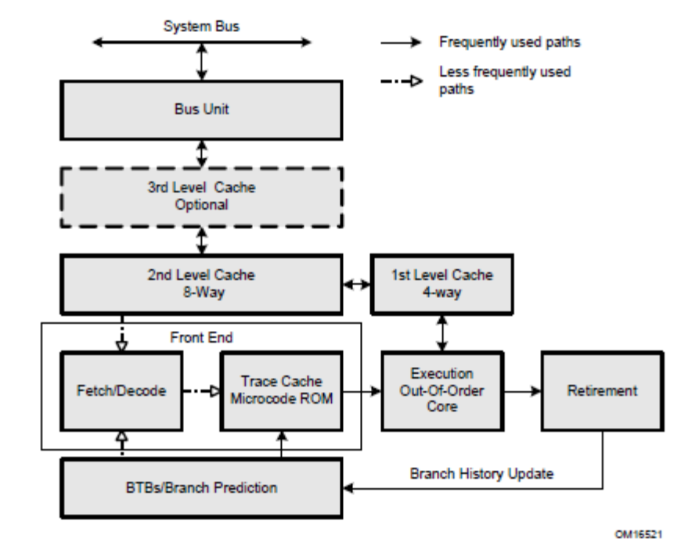
Figure 2. The Intel NetBurst Micro architecture

2.1 The Front End Pipeline
The front end supplies instructions in program order to the out-of-order execution core. It performs a number of functions:
- Pre-fetch instructions those are likely to be executed.
- Fetches instructions that have not already been prefetched.
- Decodes instructions into μ-operations.
- Generates microcode for complex instructions & special-purpose code.
- Delivers decoded instructions from the execution trace cache.
- Predicts branches using highly advanced algorithm.
The pipeline is designed to address common problems in high-speed, pipelined microprocessors. Two of these problems contribute to major sources of delays:
- Time to decode instructions fetched from the target.
- Wasted decode bandwidth due to branches or branch target in the middle of cache lines.
The operation of the pipeline’s trace cache addresses these issues. Instructions are constantly being fetched & decoded by the translation engine (part of the fetch/decode logic) & built into sequences of μops called traces. At any time, multiple traces (representing pre-fetched branches) are being stored in the trace cache. The trace cache is searched for the instruction that follows the active branch. If the instruction also appears as the first instruction in a pre-fetched branch, the fetch & decode of instructions from the memory hierarchy ceases & the pre-fetched branch becomes the new source of instructions (see Figure 2).
The trace cache & the translation engine have cooperating branch prediction hardware.
Branch targets are predicted based on their linear addresses using branch target buffers (BTBs) & fetched as soon as possible.
2.2 Out-Of-Order Execution Core
The out-of-order execution core’s ability to execute instructions out of order is a key factor in enabling parallelism. This feature enables the processor to reorder instructions so that if one μop is delayed, other μops may proceed around it. The processor employs several buffers to smooth the flow of μops. It can dispatch up to six μops per cycle. Most pipelines can start executing a new μop every cycle, so several instructions can be in flight at a time for each pipeline. A number of ALU instructions can start at two per cycle; many floating-point instructions can start once every two cycles.
2.3 Retirement Unit
The retirement unit receives the results of the executed μops from the out-of-order execution core & processes the results so that the architectural state updates according to the original program order. When a μop completes & writes its result, it is retired. Up to three μops may be retired per cycle. The Reorder Buffer (ROB) is the unit in the processor which buffers completed μops, updates the architectural state in order, & manages the ordering of exceptions. The retirement section also keeps track of branches & sends updated branch target information to the BTB. The BTB then purges pre-fetched traces that are no longer needed.

3. Intel® Core™ Micro architecture
Intel Core micro architecture introduced features for single-threaded as well as multi-threaded workloads:
- Intel® Wide Dynamic Execution enables each processor core to fetch, dispatch, execute in high bandwidths to support retirement of up to four instructions per cycle.
  - Fourteen-stage efficient pipeline.
  - Three arithmetic logical units.
  - Four decoders to decode up to five instructions per cycle.
  - Macro-fusion & micro-fusion to improve front-end throughput.
  - Peak issue rate of dispatching up to six μops per cycle.
  - Peak retirement bandwidth of up to 4 μops per cycle.
  - Advanced branch prediction.
  - Stack pointer tracker to improve efficiency of executing function/procedure entries & exits.
- Intel® Advanced Smart Cache delivers higher bandwidth from the second level cache to the core, & optimal performance & flexibility for single threaded & multi-threaded applications.
  - Large second level cache up to 4 MB & 16-way associativity.
  - Optimized for multi core & single-threaded execution environments.
  - 256 bit internal data path to improve bandwidth from L2 to first-level data cache.
- Intel® Smart Memory Access pre-fetches data from memory in response to data access patterns & reduces cache-miss exposure of out-of-order execution.
- Intel® Advanced Digital Media boost improves most 128-bit SIMD instruction with single-cycle throughput & floating-point operations.
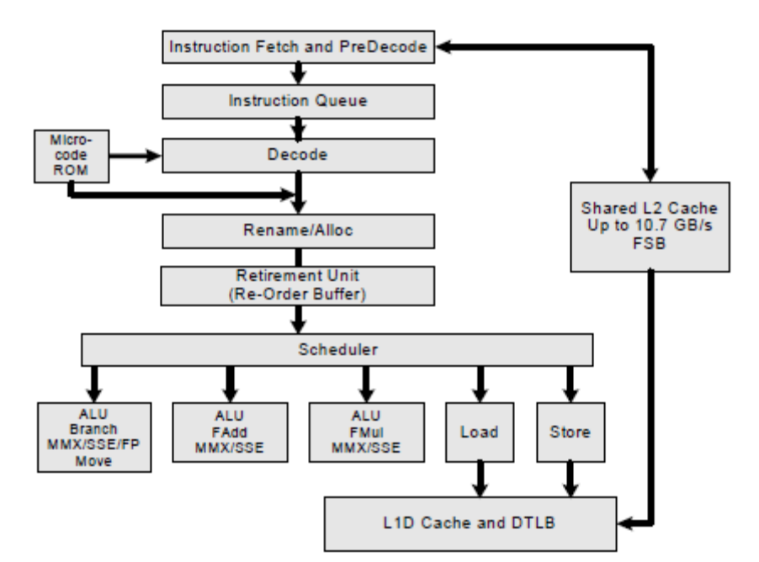
Figure 3. The Intel Core micro architecture Pipeline Functionality

4. Intel® Atom™ Micro architecture
Intel Atom micro architecture maximizes power-efficient performance for single threaded & multi-threaded workloads by providing:
- Advanced Μops Execution
  - Single-μop instruction execution from decode to retirement, including instructions with register-only, load, & store semantics.
  - Sixteen-stage, in-order pipeline optimized for throughput & reduced power consumption.
  - Dual pipelines to enable decode, issue, execution & retirement of two instructions per cycle.
  - Advanced stack pointer to improve efficiency of executing function entry/returns.
- Intel® Smart Cache
  - Second level cache is 512 KB & 8-way associativity.
  - Optimized for multi-threaded & single-threaded execution environments.
  - 256 bit internal data path between L2 & L1 data cache improves high bandwidth.
- Efficient Memory Access
  - Efficient hardware prefetchers to L1 & L2, speculatively loading data likely to be requested by processor to reduce cache miss impact.
- Intel® Digital Media Boost
  - Two issue ports for dispatching SIMD instructions to execution units.
  - Single-cycle throughput for most 128-bit integer SIMD instructions.
  - Up to six floating-point operations per cycle.
  - Up to two 128-bit SIMD integer operations per cycle.
  - Safe Instruction Recognition (SIR) to allow long-latency floating-point operations to retire out of order with respect to integer instructions.

5. Intel® Hyper-Threading Technology
Intel Hyper-Threading Technology (Intel HT Technology) was developed to improve the performance of IA-32 processors when executing multi-threaded operating system & application code or single-threaded applications under multi-tasking environments. Intel HT Technology is one form of hardware multi-threading capability in IA-32 processor families. It differs from multi-processor capability using separate physically distinct packages with each physical processor package mated with a physical socket. Intel HT Technology provides hardware multi-threading capability with a single physical package by using shared execution resources in a processor core. Architecturally, an IA-32 processor that supports Intel HT Technology consists of two or more logical processors. Unlike a traditional MP system configuration that uses two or more separate physical IA-32 processors; the logical processors in an IA-32 processor supporting Intel HT Technology share the core resources of the physical processor. This configuration allows two or more threads to be executed simultaneously on each a physical processor. Each logical processor executes instructions from an application thread using the resources in the processor core. The core executes these threads concurrently, using out-of-order instruction scheduling to maximize the use of execution units during each clock cycle.
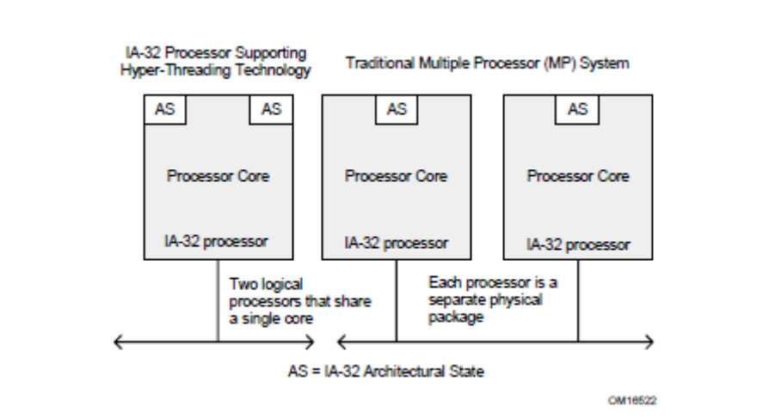
Figure 4. Comparison of an IA-32 Processor Supporting Hyper-Threading Technology & a Traditional Dual Processor System

6. SIMD Instructions
Beginning with the Pentium II & Pentium with Intel MMX technology processor families, six extensions have been introduced into the Intel 64 & IA-32 architectures to perform single-instruction multiple-data (SIMD) operations. These extensions include the MMX technology, SSE extensions, SSE2 extensions, SSE3 extensions, Supplemental Streaming SIMD Extensions 3, & SSE4. Each of these extensions provides a group of instructions that perform SIMD operations on packed integer and/or packed floating-point data elements. SIMD integer operations can use the 64-bit MMX or the 128-bit XMM registers. SIMD floating-point operations use 128-bit XMM registers. APPENDIX A-1 shows a summary of the various SIMD extensions (MMX technology, SSE, SSE2, SSE3, SSSE3, & SSE4), the data types they operate on, & how the data types are packed into MMX & XMM registers. The Intel MMX technology was introduced in the Pentium II & Pentium with MMX technology processor families. MMX instructions perform SIMD operations on packed byte, word, or double-word integers located in MMX registers. SSE extensions were introduced in the Pentium III processor family. SSE instructions operate on packed single-precision floating-point values contained in XMM registers & on packed integers contained in MMX registers. SSE2 extensions were introduced in Pentium 4 & Intel Xeon processors. SSE2 instructions operate on packed double-precision floating-point values contained in XMM registers & on packed integers contained in MMX & XMM registers. SSE2 integer instructions extend IA-32 SIMD operations by adding new 128-bit SIMD integer operations & by expanding existing 64-bit SIMD integer operations to 128-bit XMM capability. SSE3 extensions were introduced with the Pentium 4 processor supporting Hyper-Threading Technology. SSE3 offers 13 instructions that accelerate performance of Streaming SIMD Extensions technology, Streaming SIMD Extensions 2 technology, & x87-FP math capabilities. SSSE3 extensions were introduced with the Intel Xeon processor 5100 series & Intel Core 2 processor family. SSSE3 offer 32 instructions to accelerate processing of SIMD integer data. SSE4 extensions offer 54 instructions. 47 of them are referred to as SSE4.1 instructions. SSE4.1 is introduced with Intel Xeon processor 5400 series & Intel Core 2 Extreme processor QX9650. The other 7 SSE4 instructions are referred to as SSE4.2 instructions. Intel 64 architecture allows four generations of 128-bit SIMD extensions to access up to 16 XMM registers. IA-32 architecture provides 8 XMM registers.

SIMD Extensions, Register Layouts, & Data Types are discussed in APPENDIX A-1.
7. Multi-Core Technology
Multi-core technology is another form of hardware multi-threading capability in IA-32 processor families. Multi-core technology enhances hardware multi-threading capability by providing two or more execution cores in a physical package. The Intel Pentium processor Extreme Edition is the first member in the IA-32 processor family to introduce multi-core technology. The processor provides hardware multi-threading support with both two processor cores & Intel Hyper-Threading Technology. This means that the Intel Pentium processor Extreme Edition provides four logical processors in a physical package (two logical processors for each processor core). The Dual-Core Intel Xeon processor features multi-core, Intel Hyper-Threading Technology & supports multi-processor platforms.
The Intel Pentium D processor also features multi-core technology. This processor provides hardware multi-threading support with two processor cores but does not offer Intel Hyper-Threading Technology. This means that the Intel Pentium D processor provides two logical processors in a physical package, with each logical processor owning the complete execution resources of a processor core. The Intel Core 2 processor family, Intel Xeon processor 3000 series, Intel Xeon processor 5100 series, & Intel Core Duo processor offer power-efficient multi-core technology. The processor contains two cores that share a smart second level cache. The Level 2 cache enables efficient data sharing between two cores to reduce memory traffic to the system bus.

The Pentium® dual-core processor is based on the same technology as the Intel Core 2 Duo processor family. The Intel Xeon processor 7300, 5300 & 3200 series, Intel Core 2 Extreme Quad-Core processor, & Intel Core 2 Quad processors support Intel quad-core technology.
Intel Core i7 processors support Intel quad-core technology, Intel Hyper Threading Technology, provides Intel Quick Path interconnect link to the chipset & have integrated memory controller supporting three channels to DDR3 memory.

Intel 64 & IA-32 Processors that support Dual-Core & Quad-Core multi core technology are described in APPENDIX A-2 & A-3.

8. Intel® 64 Architecture
Intel 64 architecture increases the linear address space for software to 64 bits & supports physical address space up to 40 bits. The technology also introduces a new operating mode referred to as IA-32e mode. IA-32e mode operates in one of two sub-modes:
- compatibility mode enables a 64-bit operating system to run most legacy 32-bit software unmodified,
- 64-bit mode enables a 64-bit operating system to run applications written to access 64-bit address space.
In the 64-bit mode, applications may access:
- 64-bit flat linear addressing.
- 8 additional general-purpose registers (GPRs).
- 8 additional registers for streaming SIMD extensions (SSE, SSE2, SSE3 & SSSE3).
- 64-bit-wide GPRs & instruction pointers.
- Uniform byte-register addressing.
- Fast interrupt-prioritization mechanism.
- New instruction-pointer relative-addressing mode.

An Intel 64 architecture processor supports existing IA-32 software because it is able to run all non-64-bit legacy modes supported by IA-32 architecture. Most existing IA-32 applications also run in compatibility mode.
summary
The report discusses the architecture of the Intel Pentium microprocessors known as the P6 family. The P6 family was the first 32-bit family known to be having x86 architecture. P6 processor architecture introduced the concept of out-of-order execution incorporating deep branch prediction, dynamic data flow analysis & speculative execution of instructions.
The NetBurst architecture has a rapid execution engine with some modifications in the pipeline structure like branch prediction, dynamic execution core facilitating parallel execution & an improved retirement unit. The concept of trace cache was introduced with this architecture.
The Intel Core architecture has lower power consumption & improved pipeline bandwidth for fetch, dispatch and execution of data in high bandwidths. It supports smarter memory access with advanced cache system to improve data flow between L2 and L1 cache. It has an advanced dynamic execution core with SIMD instructions to improve processor throughput.
The Intel Atom architecture is extremely power efficient as it incorporates advanced micro-operations execution with the help of a bigger pipeline structure, smarter cache system optimized for threaded execution, efficient memory access & digital media boost.
The technologies which enabled further advancement in microprocessor architecture are namely, Hyper-Threading to improve performance of Intel 32-bit processors while executing threaded operations & improved SIMD instructions which provide instruction for the processor for efficient operations.
The Multi-Core micro architecture provides hardware capability for multi threaded operations with two processor cores in the same physical package, using hyper-threading technology.
Intel 64 architecture, the most advanced architecture till date, increases memory address space for software applications to 64-bits for faster access. It supports extended operation modes for compatibility with 32-bit applications.
APPENDIX
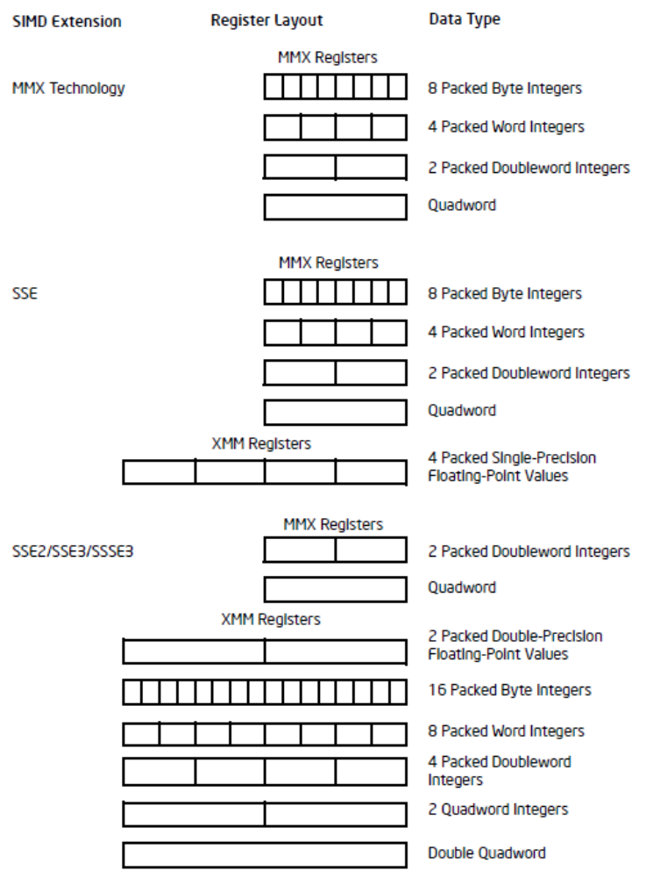
a-1 SIMD eXTENSIONS, REGISTER LAYOUT & DATATYPES
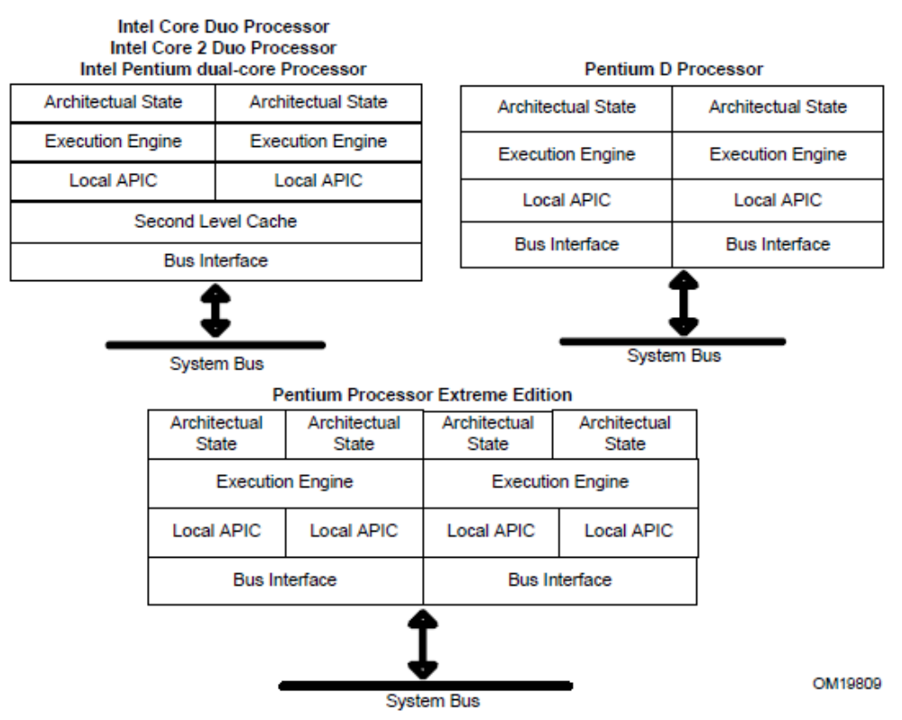
A-2 INTEL 64 & INTEL IA-32 PROCESSORS THAT SUPPORT DUAL CORE
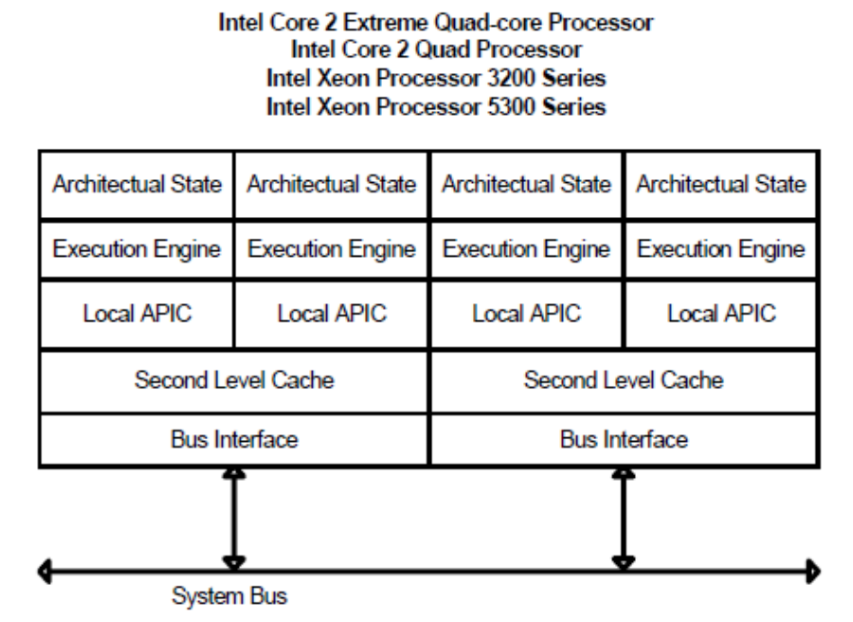
A-3 INTEL 64 PROCESSORS THAT SUPPORT QUAD CORE
A-4 INTEL IA-32 & INTEL 64 PROCESSORS WITH THEIR ARCHITECTURE AND FEATURES
Processor implementing the Architecture | Micro Architecture | Address Space / bit implementation | Features
Intel 8086, 8088 | PREVIOUS TO IA-32 ARCHITECTURE | 16-bit/20-bit (segmented) | first x86 microprocessors
Intel 80186 | PREVIOUS TO IA-32 ARCHITECTURE | 16-bit/20-bit (segmented) | hardware for fast calculations
Intel 80286 | IA-32 ARCHITECTURE | 16-bit (30-bit virtual) /24-bit (segmented) | MMU, for protected mode & a larger address space
Intel 80386 | IA-32 ARCHITECTURE | 32-bit (46-bit virtual) | 32-bit instruction set, MMU with paging
Intel 80486 | IA-32 ARCHITECTURE | 32-bit (46-bit virtual) | RISC-like pipelining, integrated FPU, on-chip cache
Intel Pentium, MMX | P6 FAMILY | 32-bit (46-bit virtual) | superscalar, 64-bit data bus, faster FPU, MMX
Intel Pentium Pro | P6 FAMILY | 32-bit (46-bit virtual) | μ-op translation, PAE, integrated L2 cache, conditional move instructions
Intel Pentium II, III Pentium II Xeon, III Xeon, | P6 FAMILY | 32-bit (46-bit virtual) | L3-cache support, 3DNow, SSE
Intel Pentium IV, Celeron D, Pentium D, Xeon | NET BURST, HYPER THREADING TECHNOLOGY | 32-bit (46-bit virtual) | deeply pipelined, high frequency, SSE2, hyper-threading
Intel Pentium M, Core | NETBRUST, CORE, INTEL 64, VIRTUALIZATION TECHNOLOGY | 64-bit | optimized for low power
Intel Pentium IV Prescott, Pentium Dual Core | NETBRUST, CORE, INTEL 64, VIRTUALIZATION TECHNOLOGY | 64-bit | very deeply pipelined, very high frequency, SSE3, 64-bit capability
Intel Core 2 | NETBRUST, CORE, INTEL 64, VIRTUALIZATION TECHNOLOGY | 64-bit | low power, multi-core, lower clock frequency, SSE4
Intel Atom | ATOM, INTEL 64 | 64-bit | In-order but highly pipelined, very-low-power
Intel Core i3, i5, i7, Xeon | NEHALEM, INTEL 64 | 64-bit | monolithic quad-core, 128 bit FPUs, SSE4a, Hyper Transport 3 or Quick Path, on-die L3 cache, native memory controller, modular design, turbo boost

A-5 INTEL IA-32 & INTEL 64 PROCESSORS WITH INSTRUCTION SET USED
INSTRUCTION SET | INTEL PROCESSORS
General Purpose | All Intel 64 & IA-32 processors
X87 FPU | Intel 486, Pentium, Pentium with MMX Technology, Celeron, Pentium Pro, Pentium II, Pentium II Xeon, Pentium III, Pentium III Xeon, Pentium 4, Intel Xeon, Pentium M, Intel Core Solo, Intel Core Duo, Intel Core 2 Duo, Intel Atom
X87 FPU & SIMD | Pentium II, Pentium II Xeon, Pentium III, Pentium III Xeon, Pentium 4, Intel Xeon, Pentium M, Intel Core Solo, Intel Core Duo, Intel Core 2 Duo, Intel Atom
Intel MMX | Pentium with MMX Technology, Celeron, Pentium II, Pentium II Xeon, Pentium III, Pentium III Xeon, Pentium 4, Intel Xeon, Pentium M, Intel Core Solo, Intel Core Duo, Intel Core 2 Duo, Intel Atom
SSE extension | Pentium III, Pentium III Xeon, Pentium 4, Intel Xeon, Pentium M, Intel Core Solo, Intel Core Duo, Intel Core 2 Duo, Intel Atom processors
SSE2 extension | Pentium 4, Intel Xeon, Pentium M, Intel Core Solo, Intel Core Duo, Intel Core 2 Duo, Intel Atom
SSE3 extension | Pentium 4 supporting HT Technology, Intel Core Solo, Intel Core Duo, Intel Core 2 Duo, Intel Xeon 3xxxx, 5xxx, 7xxx Series, Intel Atom
SSSE3 extension | Intel Xeon 3000, 3200, 5100, 5300, 7300 series, Intel Core 2 Extreme QX6000 series, Intel Core 2 Duo, Intel Core 2 Quad, Intel Pentium Dual-Core, Intel Atom
SSE4.1 extension | Intel Xeon 3100, 3300, 5200, 5400, 7400 series, Intel Core 2 Extreme QX9000 series, Intel Core 2 Quad Q9000 series, Intel Core 2 Duo 8000 series, T9000 series
SSE4.2 extension | Intel Core i7 processor
IA-32e (64-bit mode instruction) | Intel 64 processors
VMX instructions | Intel 64 & IA-32 processors supporting Intel Virtualization Technology
SMX instructions | Intel Core 2 Duo E6x50, E8xxx series; Intel Core 2 Quad Q9xxx series

SOURCES
WEBSITES:-
- http://en.wikipedia.org/wiki/Microprocessor.
- http://en.wikipedia.org/wiki/x86.
- http://en.wikipedia.org/wiki/x86-64.
- http://www.intel.com/products/processor/manuals/.

E-BOOKS:-
- Intel® 64 and IA-32 Architectures Software Developer’s Manual Volume 1: Basic Architecture.
GLOSSARY
ALU – Arithmetic & Logic Unit
CPU - Central Processing Unit
FPU – Floating Point Unit
GPR – General Purpose Register
HT – Hyper-Threading
MMX – Multi Media Extension
SIMD – Single Instruction Multiple Data
SSE – Streaming SIMD Extension
SSE2 - Streaming SIMD Extension 2
SSE3 - Streaming SIMD Extension 3
SSSE3 – Supplemental - Streaming SIMD Extension 3
SSE4 - Streaming SIMD Extension 4
VMX – Virtual Machine Extension
INDEX

A
ALU, 7
Atom, 9, 14, 17, 18

C
Cache, 8, 9
Core, 8, 12

F
FPU, 17, 18

G
GPR, 13

H
HT, 10, 18

L
L1 cache, 9
L2 cache, 8, 9, 17
L3 cache, 17

M
MMX, 11, 17, 18

N
NetBurst, 4, 6

P
Pentium, 4, 5, 11, 12, 17, 18

R
Register, 5, 6, 11, 13

S
SIMD, 8, 9, 11
SMX, 18
SSE, 11, 13, 17, 18
SSE2, 11, 13, 17, 18
SSE3, 11, 13, 17, 18
SSE4.1, 17, 18
SSE4.2, 17, 18
SSSE3, 11, 13, 17, 18

V
VMX, 18

